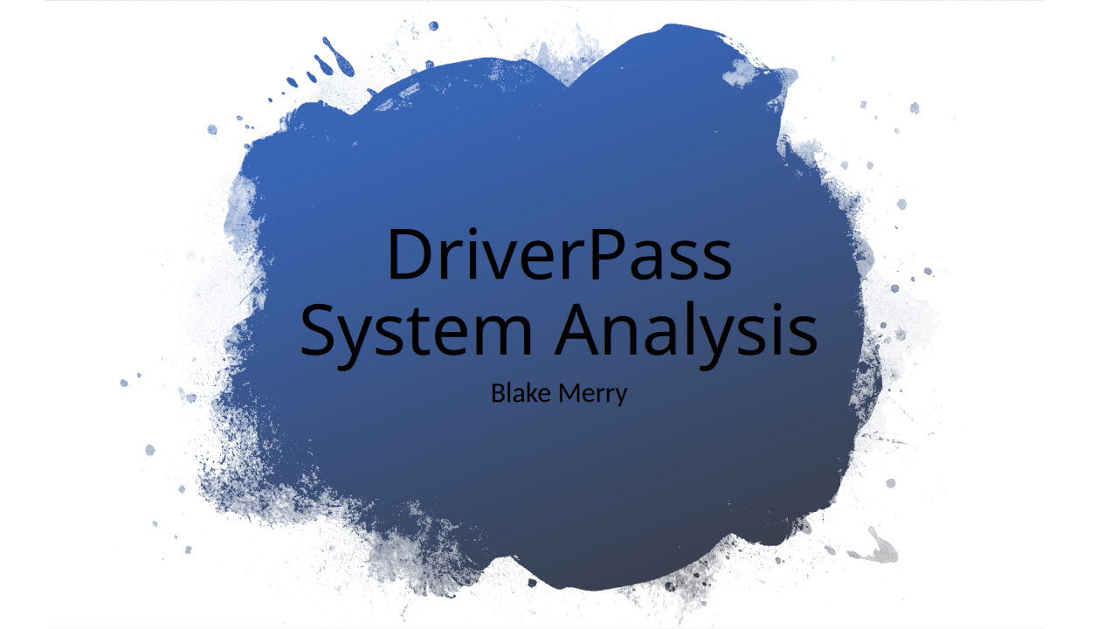
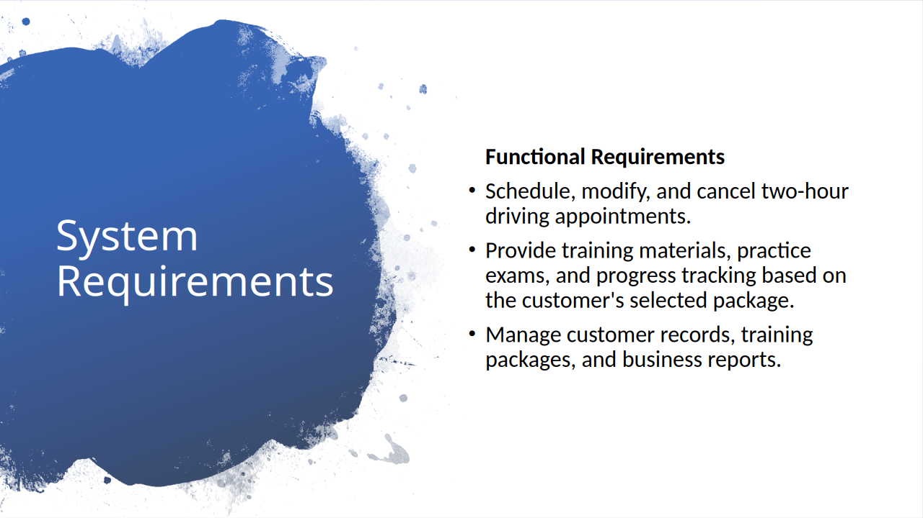

The functional requirements describe what DriverPass needs the system to actually do. One of the main priorities is appointment scheduling. Customers should be able to schedule, modify, or cancel driving lessons online, while the secretary can assist customers who call or visit the office. The system will also check instructor and vehicle availability before confirming appointments to help prevent scheduling conflicts.

Another important function is providing access to training materials and practice exams based on the customer's selected package. The system will track their progress so they can see how they're performing. On the business side, employees will have tools to manage customer information and training packages, while the owner can generate reports to monitor operations. Together, these features support both the customer experience and the day-to-day management of DriverPass.
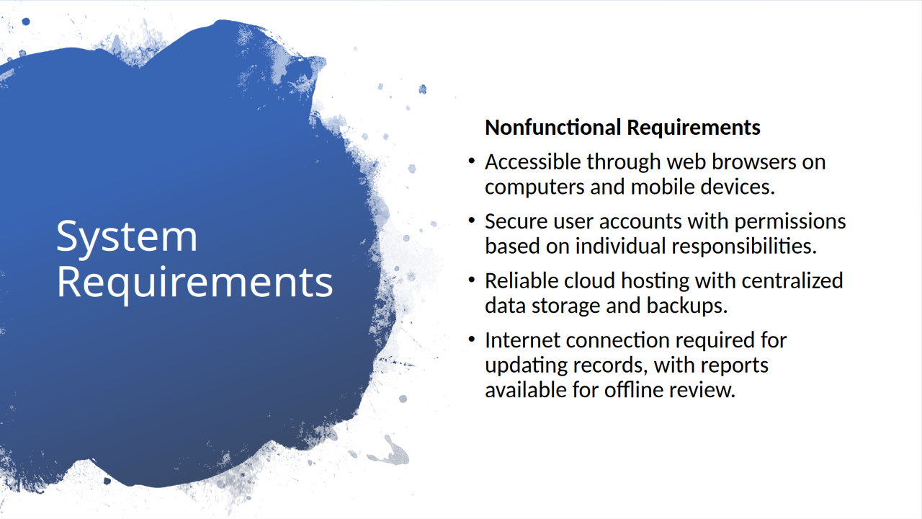

While functional requirements describe what the system does, nonfunctional requirements focus on how it should operate. DriverPass wants customers and employees to access the system from different locations and devices, so we're proposing a web-based platform that works through standard browsers without requiring separate applications.

Security and reliability are also important considerations. Each user will have access appropriate to their responsibilities, helping protect customer information and prevent unauthorized changes. We're also recommending cloud hosting so DriverPass won't need to maintain its own servers and backup infrastructure.

Finally, the system will keep its records in one central location. Users will need an internet connection to make changes, which helps prevent conflicting information, but authorized employees can still download reports for offline review. These requirements help ensure the system remains accessible, dependable, and practical for DriverPass to maintain.
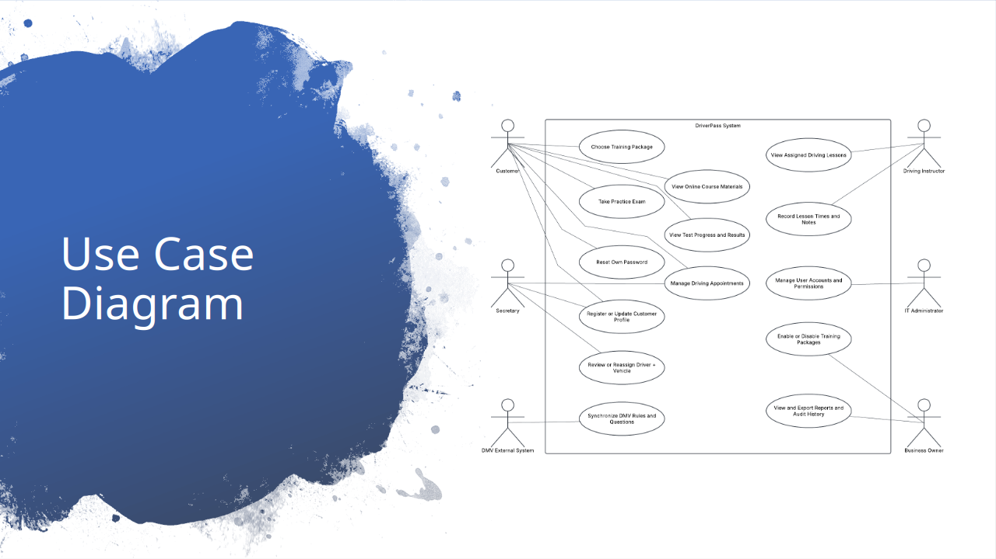

This diagram provides an overview of the different people who will interact with DriverPass and what they'll be able to accomplish through the system.

Customers can choose training packages, manage driving appointments, access online course materials and practice tests when their package includes them, and review their test results. The secretary can register or update customer information, manage appointments, and review or change driver and vehicle assignments when necessary.

Driving instructors can view their assigned lessons and record information such as lesson times and notes. The IT administrator will manage user accounts and access, while the business owner can review reports and enable or disable training packages. The system will also receive updated rules and practice questions from the DMV.

By separating these responsibilities, the design gives everyone the tools they need without providing unnecessary access to unrelated parts of the business.
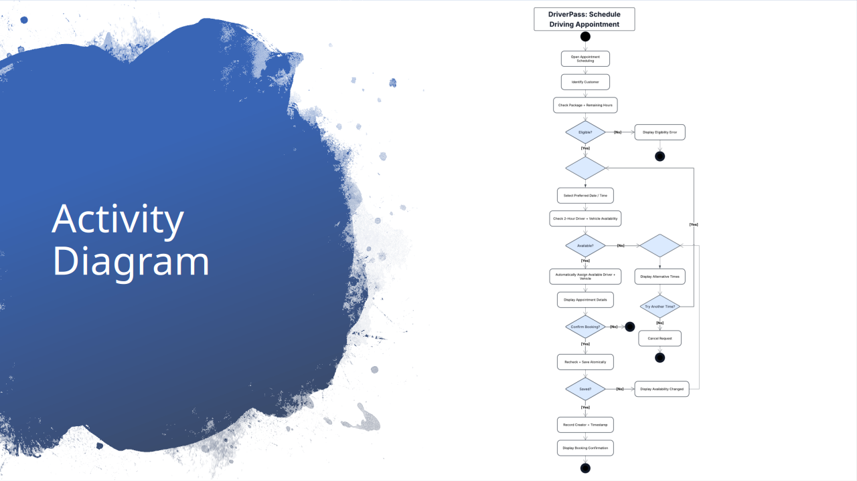

This diagram walks through the process of scheduling a new driving appointment, from the customer's initial request through confirmation.

The system first checks the customer's training package to make sure they have enough driving hours remaining for a two-hour lesson. Once their eligibility is confirmed, the customer selects a preferred date and time. The system checks whether an instructor and vehicle are available and automatically assigns them to the appointment.

If the requested time isn't available, the customer can choose another time or cancel the request. If an appointment is available, the system displays the details and asks the customer to confirm.

Before saving the reservation, the system checks availability again to make sure another customer hasn't already booked those resources. Once the reservation is saved, the system records who created it and when, then displays a confirmation. This process allows customers to schedule their own lessons while helping DriverPass avoid double-booking instructors or vehicles.
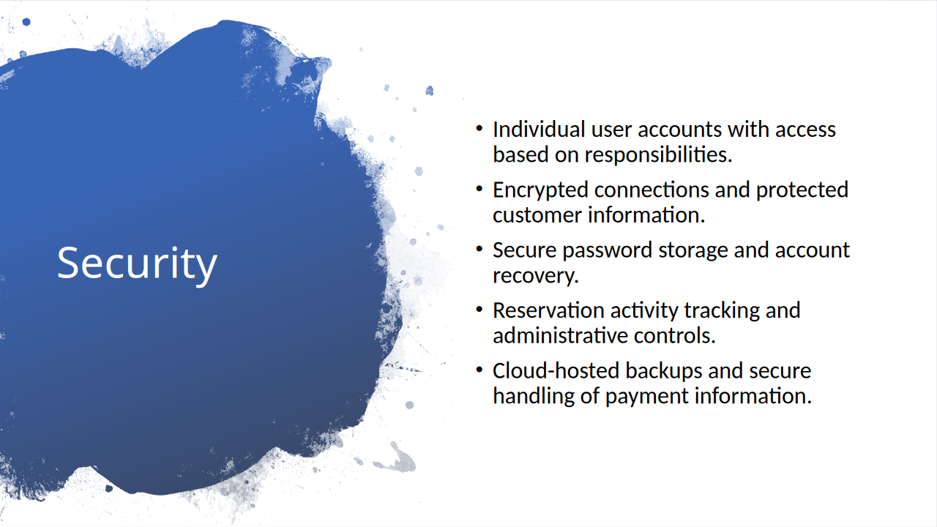

Security was an important consideration in our design because DriverPass will be handling customer information, account details, and appointment records.

Each user will have their own account, with access limited to the information and functions they need. For example, customers will manage their own appointments, while the IT administrator will have additional tools for managing employee accounts and restricting access when necessary. Connections to the system will be encrypted, and passwords will be stored securely rather than as readable text.

The system will also keep a history of reservation changes, including who created, modified, or canceled an appointment. This gives DriverPass a way to review what happened if there's ever a scheduling dispute or mistake.

Cloud-hosted backups will help protect business records against data loss. Customer payment information will also need appropriate safeguards, including not retaining card security codes after authorization.
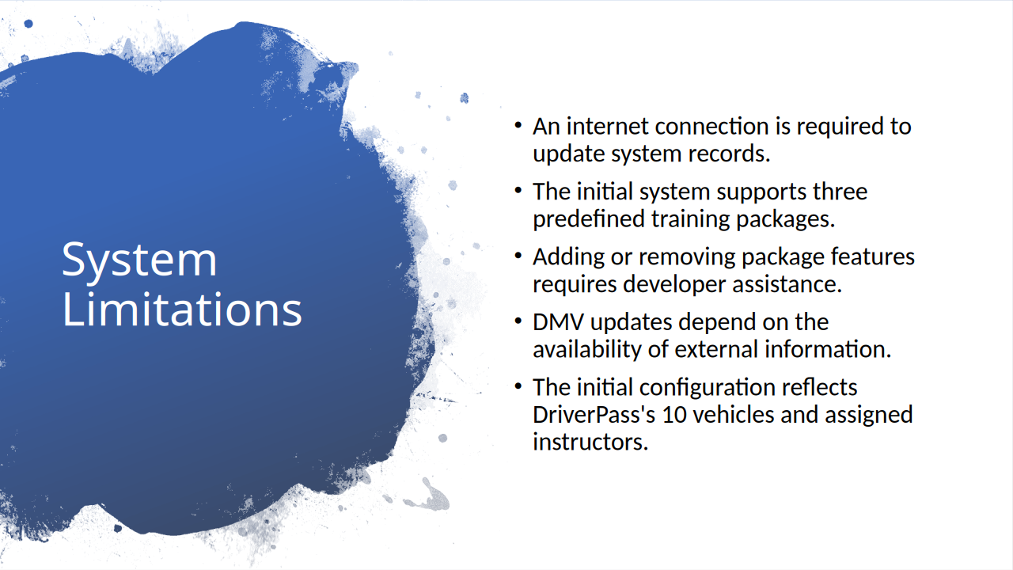

Although the proposed system addresses DriverPass's current business needs, there are a few limitations worth considering.

The first is that customers and employees will need an internet connection to access and update live information. Allowing appointments to be changed offline could create conflicting reservations, so the system will only accept changes while connected. Authorized users will still be able to download reports for offline review.

The initial system will also support the three training packages DriverPass has already established. The owner can disable an existing package, but adding new types of training or changing the components of a package would require development work.

Another limitation is that keeping training materials current depends on the DMV making updated information available electronically. The exact method for receiving those updates will need to be confirmed.

Finally, the initial configuration is based on DriverPass's current fleet of ten vehicles and their associated instructors. The design provides a foundation for future changes, but additional requirements would need to be evaluated as the business grows.

